**Hussein, Ibrahim (1936-2009)**

Ibrahim Hussein is arguably one of Malaysia’s best internationally known artists. His early works were known for their realistic figuration including, *Pak Utih* (1970) and *My Father & The Astronaut* (1970). His works were influenced by Abstract Expressionsm, as apparent in his aerial views of semi-abstract figures, entangled and rolling in fluid such as in *Tumult* (1969) and *Lovers* (1964). His later works include series that feature lines drawn with graphic pens such as *Dance of Life* (1982) and *Red, Orange & Core* (1984). These works engulf the viewer with their monumentality, fluid lines interweave with one another, engaging the viewer in a continuous journey of visual rhythm. Ibrahim Hussein also invented a technique called "printage" which combined printing techniques and collage. This technique is evident in works such as *Are You Alone Up There?* (1969), *Pak Utih* (1970), *My Father* (1972), and *Hari Ini Kita Dewasa* (1975). Ibrahim Hussein has a body of work that spans more than half a century and has left an extraordinary legacy of paintings that revolve around his perceptions of life, humanity, his country and his reflection of personal experiences throughout the years.

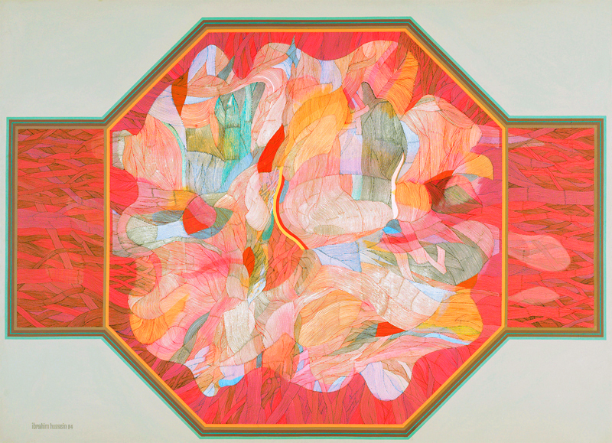

Red, Orange & Core (1984), 198 x 275cm, acrylic on canvas.

(Image taken from *Ibrahim Hussein: A Retrospective.* Kuala Lumpur: Balai Seni Lukis Negara, 1986 Permissions to be obtained.)

Ibrahim Hussein was born in 1936 in the village of Sungai Limau in Yan Kedah and began his early education at Singapore Nanyang Academy of Art in 1956. He resumed his studies at the Byam Shaw School of Drawing & Painting London between 1959 and 1963, and from 1963 to 1966, he furthered his studies at the Royal Academy in London. As his career advanced, Hussein travelled and exhibited widely throughout Europe, the United States and the Middle East. He was also the first Malaysian artist to take part in the 35th Venice Biennale in 1970, and was given the Crystal Award at the World Economic Forum in Switzerland in 1997, in addition to receiving various honours in Central America. In 2007, the Malaysian Government awarded him with the Anugerah Tokoh Melayu Terbilang and he was bestowed the ‘Datuk’ title by three different royalties. A retrospective of Hussein’s works was by the National Art Gallery, Kuala Lumpur in 1986. Hussein also founded the Ibrahim Hussein Museum and Cultural Foundation in the Langkawi which has since closed. He died on February 19, 2009 at the age of 72 years.

**References and further reading**

---- (1986) *Ibrahim Hussein: A Retrospective.* Kuala Lumpur: Balai Seni Lukis Negara.

Piyadasa, Redza. (2002) *Masterpieces from the National Art Gallery of Malaysia* Kuala Lumpur: Balai Seni Lukis Negara.

Sabapathy, T.K., and Piyadasa, Redza. (1983) *Modern Artists of Malaysia*. Kuala Lumpur: Dewan Bahasa dan Pustaka.